Year Round Growing Curriculum

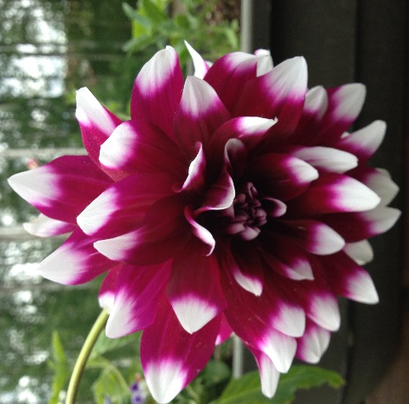
Plant Parts: Flowers
Author/Source: Alaska Botanical Garden and Adapted from ASAP's
Growing Minds lesson plans and OER Flower Power

Suggested Grade Levels: Elementary

Time: 45 minutes

Teaching Goal: To use real flowers and a simple diagram to dissect a perfect flower and learn about pollination and how plants make fruits and seeds.

Learning Objectives: As a result of this lesson students should be able to identify parts of a flower, including the pistil, sepals, petals, stamen, filament, anther, ovary, style, and
stigma. Students should understand each part’s function and role within the flower
and the flower’s environment.

Core Ideas:
- Plant Anatomy
- Plant Life Cycles
- Plant Dynamics (circulation and nutrient uptake)
- Evapotranspiration and Transpiration
- Recording Scientific Data in Tables
- Standardized Science Measurements
- Drawing Conclusions from Experimentation (hands-on, observation, drawing, and note-taking)

Alaska State Science Standards: Science: 2-LS4-1, 3-LS4-4, 4-LS1-1, 5-LS1-1, 5-LS2-1, MS-LS1-1, MS-LS1-2, MS-LS1-4

NGSS Standards: 2-LS2-1, 2-PS1-1, 3-LS1-1, 4-LS1-1, 5-LS1-1, MS-LS1-1, MS-LS1-2

Materials Needed:
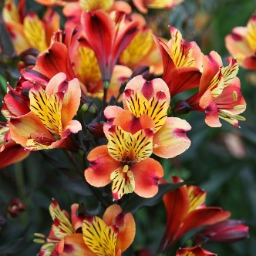
- Magnifiers
- Parts of a Flower diagram
- Crayons, colored pencils, or markers
- Paper
- Pencils
- Flowers with discernible reproductive parts, enough for each child to have 2
- Alstroemeria is a good, complete flower to use
- Magnifiers Alstroemeria
- Toothpicks
- Paper towels

Vocabulary:
- Petals: Different colors, shapes and smells designed to attract pollinators.
- Sepals: Green leaf-like parts under the petals that hold the petals together.
- Stamen: The male part of the flower that holds the pollen at the very top.
- Pollen: Is a powder-like grain that travels from flower to flower.
- Pistil: The female part of the flower that holds the seeds.
- Pollinator: Anything that moves pollen from one flower to another
- Angiosperms: The angiosperms are vascular plants in which the ovule (egg) is fertilized and develops into a seed in an enclosed hollow ovary.

Background for Teachers:
The primary function of all flowers is to produce seeds. Seeds are needed by plants
to reproduce. The shape, color, smell, and size of the flower all play crucial roles in
helping the flower produce seeds. Flowers must first be pollinated in order to make
seeds.

Parts of the Flower:
Each part of the flower contributes to the flower’s role of making seeds. The pistil is
the female part of the flower and is made up of the stigma, style, ovary, and ovule.
Each pistil is made up of one or many leaf‐like structures. The ovary is the enlarged
base where seeds develop to fruit and where ovules await fertilization. The ovule is
the part of the ovary that turns into seeds. The style is a long stalk that comes out of
the base of the ovary and holds up the stigma. The stigma is the sticky bulb at the
center of the flower. Pollen grains attach to the stigma and germinate, producing
seeds and fruit. The male part of the flower is called the stamen and is composed of
the anther and filament. The stamen produces pollen. The filament is a thin
structure, which supports the anther. The anthers are filled with pollen. When the
pollen is ready to be spread, the anthers open up and curl back to release pollen.
The pollen is picked up by pollinators or the wind and transferred between flowers.
The role of the petals is to attract certain animals to the flower for pollination.
Petals come in a variety of colors, shapes, and smells in order to attract certain
pollinators. The sepals are leaf‐like parts at the bottom of the flower and help
protect the developing bud. Sepals are mostly green, except for lilies and tulips,
which are colorful. A group of sepals is called a calyx.
Flowers can have all male parts, all female parts, or a combination of male and
female parts. Flowers with all male or female parts are labeled imperfect and
include, cucumbers, pumpkins, and melons. Flowers that have both male and female
parts are labeled perfect and include roses, lilies, dandelions, tomatoes.

Procedure:
- Ask the students: What is a flower? What is your favorite kind of flower? Why do flowers exist and what does it do for the plant? We know that they provide us with beauty and wonderful aromas, but what is their function in nature?

Flowers are the parts of the plant that produce seeds.
Plants make seeds only after pollination.
Depending on the plant species, a flower may have male, female, or both males and female reproductive structures.
A flower with both male and female parts is called a perfect or complete flower.
Flowers that have only male or only female parts are not often located on the same plant. Some plants are actually male, and some are female.

- Ask the students if they have ever heard of pollination. Most flowers depend on bees, birds, or other insects to help with the pollination process. Smell, color, and nectar attract pollinators to the flower.

- Explain that now the class will be taking a closer look at flower parts. Hand out one flower and a magnifier to each student. Also, give them a toothpick and a paper towel.

- Hand each student a copy of the flower part diagram. Different parts of the flower are specialized to help plants reproduce—to produce seeds that are used in new plant growth. Typical flowers have four main parts: pistil (stigma, ovary, and style), stamen (anther and filament), petals, and sepals.

- Start with the petals. Have them remove one petal and look at it with the magnifying glass.

Petals are the colorful structures that help the flower attract pollinators. Petals also serve as a landing platform for insects and birds. For example, when a bee lands on the lower petal of a snapdragon, its weight causes the stamen to swing down and dust the bee with pollen. Petals of some plant species have stripes or other markings that guide pollinators to the nectar.

- Next look at the pistil. Hold the flower with one hand at the base of the petals. Using the toothpick or fingernails, open the flower up. Find the Pistil. The pistil is the female part of the flower. The pistil includes the ovary, style, and stigma.

Have them touch the stigma. See how it is sticky. Pollen, brought to the flower either from an insect or the wind, will attach to the sticky stigma and this begins the process of pollination.

Next look below the stigma to see the tube-like style. The pollen travels down the style until it reaches the ovary where ovules are fertilized and will develop into seeds.
Have them open the large bulb like ovary and look at the developing seeds with the magnifying glass.

- Next look at the stamen. The stamen is the male part of the flower. It consists of the anther and filament. The anther carries the pollen that fertilizes the female part of the flower and is held up by the thread-like filament.

Use the toothpick to separate the anther from the filament. Look at each with the magnifying glass.

- Next, have students draw their second flowers in their science journals, diagramming the parts.

- Review the parts of the flower with them.

Worksheets: Parts of a Flower diagram, Parts of a Flower Worksheet

Extensions: Do You Know the Parts of Plants?, Reading a Seed Packet, Starting Plants in the Classroom. Creating Paper Flowers or Flower Poetry (Directions at the end of the lesson)

Assessment:
If students journaled their observations in their science journal you can grade for inclusion of all suggested observations.
You can also consider assessing whether or not they participated.
You can easily extend this activity into reading or writing and assess based on those activities.
You can assess completion and accuracy of the worksheet

References:
Books:
Attracting Native Pollinators: Protecting North America’s Bees and Butterflies by the Xerces ISBN: 978-1-60342-695-4 2011

The Budding Botanist (AIMS Activities Grades 3-6) Investigations with Plants
by Evalyn Hoover, Howard Larimer, Sheryl Mercier, Michael Walsh, Dave Youngs and Beverly Tillman 2009 ISBN: 1-881431-40-1

Websites:
http://www.biologycorner.com/worksheets/flower_coloring.html a good site with some questions and a diagram:

And another good one: http://www.ext.colostate.edu/mg/gardennotes/135.html

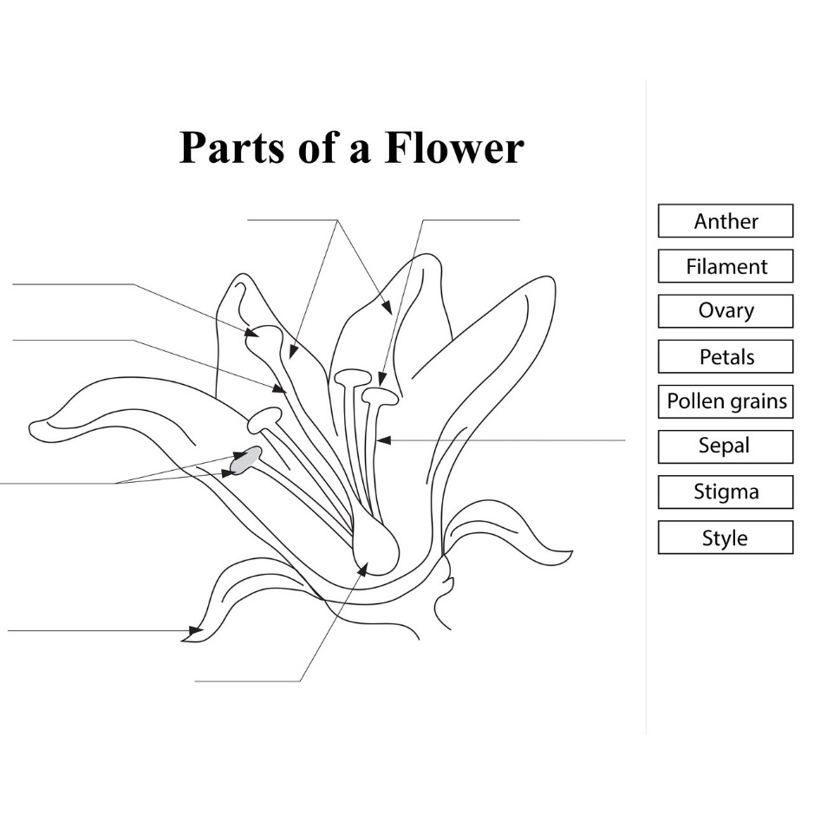

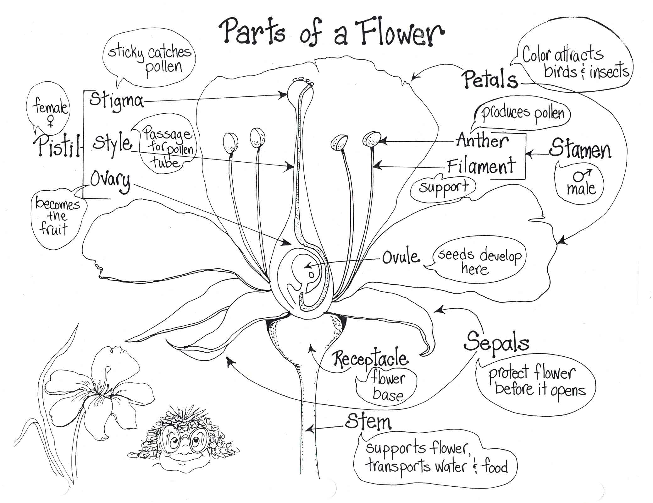
Image from “Budding Botanist: Investigations with Plants” by AIMS
Optional Extensions
Creating Paper Flowers
- Create leaves with cut‐out pieces of construction paper
- Put 3‐6 pieces of tissue paper (5X7 inches) in a pile
- Fold pieces into an accordion (about 2 inches with each fold)
- Tie the center of the folded paper with a pipe cleaner or twist tie, serving as the
stem
- Use scissors to cut the ends of the tissue paper into desired shape (optional)
- Pull each layer of tissue paper out around the stem, creating petals
- To create anthers and filaments: Glue Q‐Tips to tissue paper (soft tip acts as the
anther, while the stem acts as the filament)
- To create a pistil: use precut pieces of construction paper cut out in the shape of a bowling pin
- Show class that the long area is the style, while the rounded area is the ovary
- Attach large felt pompoms with glue to represent the stigma (attached to
end of style) and smaller felt pompoms to represent the ovules (inside the
ovary)
- Have students come up to the front of the class to present their paper flowers

Flower Poetry (Adapted from Project Seasons)
- Read aloud poetry about different flowers or plants.
- Choose poems that do not mention the plant by name, or leave out the name while
Reading.
- Ask students to guess the identity of the plant or flower.
- Pass around different types of flowers.
- Ask students to write a poem about a chosen flower, but do not mention the name
of the flower in the poem—the identity of the flower must be kept a secret!
- Ask students to divide into pairs.
- Students read their poems to one another and their partner guesses the type of flower being described.

